Europeans are very much divided in the fight against climate change
Belgium | BE | Croatia | HR | Netherlands | NL
Bulgaria | BG | Ireland | IE | Austria | AT
Czech Republic | CZ | Italy | IT | Poland | PL
Denmark | DK | Cyprus | CY | Portugal | PT
Germany | DE | Latvia | LV | Romania | RO
Estonia | EE | Lithuania | LT | Slovenia | SI
Greece | EL | Luxembourg | LU | Slovakia | SK
Spain | ES | Hungary | HU | Finland | FI
France | FR | Malta | MT | Sweden | SE

Pierre Dieumegard,
21 February 2022

In autumn 2021, the European Union commissioned the Special Eurobarometer 517 “The Future of Europe”, with more than 25,000 respondents, distributed by country, gender, age and social groups.
Question QA17 asked: “In your opinion, which of the following are the main global challenges for the future of the EU?”
The list of possible responses was [Environmental Problems and Climate Change, Health Risks, Migration and Forced Displacement, Terrorism, Organised Crime, Deteriorating International Relations, Cyber Warfare and New Forms of Conflict, The Future Rise of Populism, Risks Resulting from New Technologies, Rapid Changes in Population, Regression of the European Population from the rest of the World]
The most frequently cited response was environmental problems and climate change (49 % for the EU as a whole).
RO
LV
EE
BG
HU
PL
SK
LT
CZ
HR
studies 15 or —
At home
IT
studies 16-19
EL
SI
age > 55
Workers
Pensioners
MT
Men
Independents
Other employees
IE
CY
LU
EU27
Woman
age 40-54
Unemployed
ES
AT
FI
age 25-39
FR
age 15-24
BE
PT
studies 20 and +
Always student
Senior management
DE
DK
NL
SE
0
10
20
30
40
50
60
70
QA17 Important challenge for the EU:
environmental issues and climate change
But this average hides great disparities: the “Eastern countries” are much less motivated by the fight against climate change than others.

Only 25 % of Romanians attach importance to the environment compared to 72 % of Swedes, three times less. In comparison, there is no difference between the sexes. Although young people are somewhat more concerned about the environment than older people, the difference is only a few percentage points.

Question QA20 concerned the same theme, but with a somewhat different wording, more action-oriented: “Of the following, what are the two elements that our society should focus onto address key global challenges? (Maximum 2 answers)”
The list was: [Environment and climate change, Equality and social justice, Health and safety Education, Progress and Innovation, Free Trade and Market Economy, Cultural Diversity and Openness to Others, Traditions, Industrial Capacity of the European Union].

Again, the differences between countries are greater than between social groups. Only 12 % of Romanians want firm action for the environment and climate change, compared to 74 % of Danes, six times as many. Even though senior managers give more importance to the fight against climate change than the unemployed, the difference is only a few percentage points.

Conclusion: it is difficult to get all Europeans into a common environmental policy. The differences between countries are much greater than between social groups: the inhabitants of one country do not understand the concerns of the inhabitants of another country.
RO
BG
EL
PT
PL
LV
HU
EE
IT
LT
studies 15 or —
SK
At home
HR
AT
Workers
studies 16-19
ES
age 40-54
CZ
age > 55
Pensioners
CY
Men
Woman
Other employees
Unemployed
age 25-39
Independents
age 15-24
SI
Always student
Students
FI
studies 20 and +
Senior management
FR
BE
DE
IE
LU
MT
NL
SE
DK
0
10
20
30
40
50
60
70

QA20 To address global challenges, society should focus on:
environment and climate change
It is likely that these differences between countries are linked to differences between languages. Public opinion at the European level requires a public debate at the European level, and therefore a common language. The best common language would be Esperanto, a simple language to learn, precise and fair.
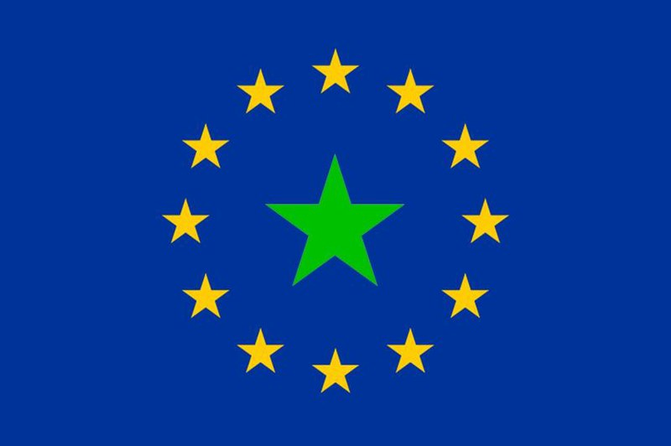https://www.europo.eu

https://uea.org

