

First European Survey on Language Competences

Executive Summary

Table of contents
Background to the Survey 3
Conducting the Survey 3
Findings: language proficiency 5
Overall Performance 5
Performance by educational system 6
Performance by language 8
Creating a European indicator for languages 9
Findings: the contextual questionnaires 11
Challenges for language learning in Europe 13

Document prepared by Pierre Dieumegard for Europe-Democracy-Esperanto
The purpose of this "provisional" document is to enable more people in the European Union to become aware of documents produced by the European Union (and financed by their taxes).
If there are no translations, citizens are excluded from the debate.
This document “Surveylang” only existed in English, in a pdf-file . From the initial file, we created a odt-file, prepared by Libre Office software, for machine translation to other languages. The results are now available in all official languages.

It is desirable that the EU administration takes over the translation of important documents. “Important documents” are not only laws and regulations, but also the important information needed to make informed decisions together.
In order to discuss our common future together, and to enable reliable translations, the international language Esperanto would be very useful because of its simplicity, regularity and accuracy.

Contact us :
Kontakto (europokune.eu)
https://e-d-e.org/-Kontakti-EDE

Background to the Survey
This Executive Summary presents a brief overview of the European Survey on Language Competences (ESLC) and its most important findings. The full analysis is presented in two documents: First European Survey on Language Competences: Final Report and First European Survey on Language Competences: Technical Report.
The ESLC was established to provide participating countries with comparative data on foreign language competence and insights into good practice in language learning; ‘not only … a survey of language competences but a survey that should be able to provide information about language learning, teaching methods and curricula’. The ESLC is also intended to enable the establishment of a European language competence indicator to measure progress towards the 2002 Barcelona European Council Conclusions, which called for ‘action to improve the mastery of basic skills, in particular by teaching at least two foreign languages from a very early age’. It is the first survey of its kind.
In 2005 the European Commission outlined a detailed strategic approach for the ESLC. The contract for the survey was awarded in 2008 to the SurveyLang Consortium, a group of eight expert organisations in the fields of language assessment, questionnaire design, sampling, translation processes and psychometrics. The main study was carried out in spring 2011.
An Advisory Board comprising representatives of all EU Member States and the Council of Europe provided strong support for the European Commission throughout the process of developing and implementing the survey.

Conducting the Survey
Fourteen European countries took part in the survey: Belgium, Bulgaria, Croatia, Estonia, France, Greece, Malta, Netherlands, Poland, Portugal, Slovenia, Spain, Sweden and UK-England. Belgium’s three linguistic communities participated separately to give a total of 16 educational systems. The survey for England was conducted a few months later and is reported in an appendix to the main ESLC report.
The ESLC collected information about the foreign language proficiency of European pupils in the last year of lower secondary education (ISCED2) or the second year of upper secondary education (ISCED3). Note that in some educational systems these levels are considered to be primary education. Only pupils who had had instruction in the foreign language for at least one whole school year were eligible. The level chosen reflected the organisation of language learning in different countries, e.g. the age at which pupils begin to learn a second foreign language.
This first administration of the ESLC tested a representative sample of almost 54,000 pupils. Each educational system tested the two languages most widely taught in that entity (so-called first and second foreign languages) from the five tested languages: English, French, German, Italian and Spanish. Each sampled pupil was tested in one language only.

The survey was completed to international education survey standards similar to surveys such as PISA, PIRLS and TIMSS.
The language tests covered three language skills: Listening, Reading and Writing (Speaking was considered logistically difficult for this first round). Each pupil was assessed in two of these three skills. Each pupil received a test at an appropriate level on the basis of a routing procedure. This targeted approach favoured the collection of more valid responses.
The ESLC was administered in both paper and computer-based formats.
The results of the survey are reported in terms of the levels of the Common European Framework of Reference for Languages: teaching, learning and assessment (CEFR). The CEFR has been widely adopted in Europe and beyond as a framework for language education, and also for developing a shared understanding of levels of language competence. It defines six levels of functional competence from A1 (the lowest level) to C2. The ESLC focused on levels A1 to B2. It was also necessary to define a pre-A1 level in order to identify an A1 threshold.
The terms "basic user" and "independent user" are adopted to designate the broad A and B levels, as well as denotations for each of the five levels, as shown in Table 1.

Table 1: Overview of ESLC and CEFR levels
 | ESLC level |  |  |  | CEFR level |  |  | Definition
Independent user |  | Advanced independent user |  | B2 |  |  | An independent language user who can express herself clearly and effectively
 |  | Independent user |  | B1 |  |  | An independent language user who can deal with straightforward, familiar matters
Basic user |  | Advanced basic user |  | A2 |  |  | A basic user who can use simple language to communicate on everyday topics
 |  | Basic user |  | A1 |  |  | A basic user who can use very simple language, with support
Beginner |  |  |  | Pre-A1 |  |  | A learner who has not achieved the level of competence described by A1

Much effort was devoted to making the language tests comparable over the five tested languages in terms of the skills measured and interpretation in terms of Common European Framework levels. Examples of the language test tasks are included in the ESLC Final Report.

Additional information collected for validation of standards included a multilingual study comparing samples of writing, and a section in the questionnaire where pupils were asked to self-assess their language skills on 16 Common European Framework can-do statements.
Questionnaires were administered to the pupils tested and to the foreign language teachers and principals in their institutions. In addition, system-wide information was collected through the National Research Coordinators.

Findings: language proficiency

Overall Performance
Language competences provided by educational systems still need to be significantly improved
The ESLC results show an overall low level of competences in both first and second foreign languages tested. The level of independent user (B1+B2) is achieved by only 42% of tested students in the first foreign language and by only 25% in the second foreign language. Moreover, a large number of pupils did not even achieve the level of a basic user: 14% for the first and 20% for the second foreign language.

Table 2: Percentage of pupils achieving each CEFR level in first and second foreign language (global average across educational systems)
Tested language | Pre-A1 | A1 | A2 | B1 | B2
First foreign language | 14 | 28 | 16 | 19 | 23
Second foreign language | 20 | 38 | 17 | 14 | 11

Table 3 provides a summary of results per skill. It confirms that for all tested skills results are better for the first foreign language: the level of independent user (B1+B2) for Reading, Listening and Writing averaged across educational systems (the unweighted average) are respectively 41%, 45% and 40% for the first foreign language compared to 27%, 27% and 22% for the second one.

 |  |  |  | First foreign language |  |  |  |  | Second foreign language
Level |  |  | Reading |  | Listening | Writing |  | Reading |  | Listening | Writing
B2 - Advanced independent user |  |  | 27 |  | 30 | 13 |  | 15 |  | 14 | 5
B1 - Independent user |  |  | 14 |  | 15 | 27 |  | 12 |  | 13 | 17
A2 - Advanced basic user |  |  | 12 |  | 13 | 24 |  | 13 |  | 16 | 21
A1 - Basic user |  |  | 33 |  | 25 | 25 |  | 41 |  | 37 | 36
Pre-A1 - Beginner |  |  | 14 |  | 17 | 11 |  | 19 |  | 20 | 21

Higher achievement in the first foreign language is not unexpected, given the generally earlier onset and greater amount of study. In the majority of participating countries or language communities the first foreign language is compulsory, but not the second one. In addition, in most educational systems, the first foreign language is English and the exposure to this language through internet and other traditional and new media is higher. A key finding of the ESLC is that these factors contribute to relatively better results in English than other languages. Actually, even in educational systems where English is the second foreign language, the performance in English tends to be higher than in the other language tested. Further evidence of the particular status of English comes from the pupils' questionnaire responses, their reported perception of its usefulness, and their degree of exposure to it and use of it through traditional and new media.

Performance by educational system
There is a wide range of ability across countries in Europe
The proportion of pupils reaching each level varies greatly among educational systems, for all languages (both first and second foreign language) and skills.
The Survey shows that for the first foreign language, the proportion of students reaching the level of independent user varies from 82% in Malta and Sweden (English) to only 14% in France (English) and 9% in England (French).
For the second foreign language (not English), the level of independent user is reached by 4% in Sweden (Spanish) and 6% in Poland (German) compared to 48% in the Netherlands (German).
The final report contains detailed results by educational system, first and second foreign language, and skill.
Many educational systems show high levels of achievement. However, for the first foreign language there are six educational systems in which at least 20% of pupils do not achieve the level of basic user (A1) in one or more skills. For the second foreign language the same is true of nine educational systems, although it is important to note that much shorter duration of study may be a factor here.
The wide range of achievement is not observed solely at educational system level – for example, Sweden performs very well in the first foreign language (English) but much less so in the second foreign language (Spanish). Differences should be evaluated carefully, taking into account the range of factors which make simple comparison of performance difficult: the grade pupils are in, their average age, the number of years the language has been studied - all can vary across the educational systems.
Tables 4 and 5 show for first and second foreign language the results by educational system, grouped by broad basic (A) and independent (B) user levels.
Table 4: First foreign language - percentage of pupils achieving broad levels by skill and educational system
 | Educational system
 |  |  |  | Language |  |  | Reading |  |  |  |  |  |  |  |  | Listening |  |  |  |  |  |  |  |  | Writing
 |  |  |  |  |  |  | Pre-A1 |  |  |  |  |  |  |  |  | Pre -A1 |  |  |  |  |  |  |  |  | Pre -A1
 |  |  |  |  |  |  |  |  |  | A |  |  | B |  |  |  |  |  | A |  |  | B |  |  |  |  |  | A |  |  | B
Bulgaria |  |  | English |  |  | 23 |  |  | 43 |  |  | 34 |  |  | 23 |  |  | 37 |  |  | 40 |  |  | 15 |  |  | 52 |  |  | 32
Croatia |  |  | English |  |  | 16 |  |  | 44 |  |  | 40 |  |  | 12 |  |  | 32 |  |  | 56 |  |  | 5 |  |  | 49 |  |  | 45
Estonia |  |  | English |  |  | 7 |  |  | 33 |  |  | 60 |  |  | 10 |  |  | 27 |  |  | 63 |  |  | 3 |  |  | 37 |  |  | 60
Flemish Community of Belgium |  |  | French |  |  | 12 |  |  | 63 |  |  | 24 |  |  | 17 |  |  | 62 |  |  | 20 |  |  | 19 |  |  | 59 |  |  | 22
France |  |  | English |  |  | 28 |  |  | 59 |  |  | 13 |  |  | 41 |  |  | 46 |  |  | 14 |  |  | 24 |  |  | 61 |  |  | 16
French Community of Belgium |  |  | English |  |  | 10 |  |  | 59 |  |  | 31 |  |  | 18 |  |  | 55 |  |  | 27 |  |  | 6 |  |  | 65 |  |  | 29
German Community of Belgium |  |  | French |  |  | 10 |  |  | 52 |  |  | 38 |  |  | 11 |  |  | 49 |  |  | 40 |  |  | 8 |  |  | 51 |  |  | 41
Greece |  |  | English |  |  | 15 |  |  | 40 |  |  | 45 |  |  | 19 |  |  | 35 |  |  | 46 |  |  | 7 |  |  | 41 |  |  | 53
Malta |  |  | English |  |  | 4 |  |  | 17 |  |  | 79 |  |  | 3 |  |  | 11 |  |  | 86 |  |  | 0 |  |  | 17 |  |  | 83
Netherlands |  |  | English |  |  | 4 |  |  | 36 |  |  | 60 |  |  | 3 |  |  | 21 |  |  | 77 |  |  | 0 |  |  | 39 |  |  | 60
Poland |  |  | English |  |  | 27 |  |  | 49 |  |  | 24 |  |  | 27 |  |  | 45 |  |  | 28 |  |  | 19 |  |  | 59 |  |  | 23
Portugal |  |  | English |  |  | 20 |  |  | 53 |  |  | 26 |  |  | 23 |  |  | 39 |  |  | 38 |  |  | 18 |  |  | 55 |  |  | 27
Slovenia |  |  | English |  |  | 12 |  |  | 42 |  |  | 47 |  |  | 5 |  |  | 28 |  |  | 67 |  |  | 1 |  |  | 51 |  |  | 48
Spain |  |  | English |  |  | 18 |  |  | 53 |  |  | 29 |  |  | 32 |  |  | 44 |  |  | 24 |  |  | 15 |  |  | 58 |  |  | 27
Sweden |  |  | English |  |  | 1 |  |  | 18 |  |  | 81 |  |  | 1 |  |  | 9 |  |  | 91 |  |  | 0 |  |  | 24 |  |  | 75
UK England |  |  | French |  |  | 22 |  |  | 68 |  |  | 10 |  |  | 30 |  |  | 62 |  |  | 8 |  |  | 36 |  |  | 54 |  |  | 10

Table 5: Second foreign language - percentage of pupils achieving broad levels by skill and educational system

 | Educational system
 |  |  |  | Language |  |  | Reading |  |  |  |  |  |  |  |  | Listening |  |  |  |  |  |  |  |  | Writing
 |  |  |  |  |  |  | Pre -A1 |  |  |  |  |  |  |  |  | Pre -A1 |  |  |  |  |  |  |  |  | Pre -A1
 |  |  |  |  |  |  |  |  |  | A |  |  | B |  |  |  |  |  | A |  |  | B |  |  |  |  |  | A |  |  | B
Bulgaria |  |  | German |  |  | 24 |  |  | 51 |  |  | 25 |  |  | 25 |  |  | 52 |  |  | 22 |  |  | 24 |  |  | 60 |  |  | 16
Croatia |  |  | German |  |  | 29 |  |  | 57 |  |  | 13 |  |  | 23 |  |  | 61 |  |  | 16 |  |  | 20 |  |  | 69 |  |  | 11
Estonia |  |  | German |  |  | 17 |  |  | 56 |  |  | 27 |  |  | 15 |  |  | 60 |  |  | 24 |  |  | 10 |  |  | 68 |  |  | 22
Flemish Community of Belgium |  |  | English |  |  | 2 |  |  | 18 |  |  | 80 |  |  | 1 |  |  | 12 |  |  | 87 |  |  | 0 |  |  | 27 |  |  | 72
France |  |  | Spanish |  |  | 18 |  |  | 68 |  |  | 14 |  |  | 19 |  |  | 71 |  |  | 10 |  |  | 24 |  |  | 68 |  |  | 8
French Community of Belgium |  |  | German |  |  | 14 |  |  | 62 |  |  | 24 |  |  | 13 |  |  | 59 |  |  | 28 |  |  | 4 |  |  | 66 |  |  | 29
German Community of Belgium |  |  | English |  |  | 3 |  |  | 44 |  |  | 53 |  |  | 4 |  |  | 32 |  |  | 64 |  |  | 0 |  |  | 43 |  |  | 57
Greece |  |  | French |  |  | 35 |  |  | 54 |  |  | 10 |  |  | 37 |  |  | 52 |  |  | 11 |  |  | 49 |  |  | 35 |  |  | 16
Malta |  |  | Italian |  |  | 16 |  |  | 50 |  |  | 34 |  |  | 17 |  |  | 37 |  |  | 46 |  |  | 31 |  |  | 46 |  |  | 23
Netherlands |  |  | German |  |  | 3 |  |  | 43 |  |  | 54 |  |  | 1 |  |  | 39 |  |  | 60 |  |  | 1 |  |  | 68 |  |  | 31
Poland |  |  | German |  |  | 41 |  |  | 53 |  |  | 6 |  |  | 45 |  |  | 50 |  |  | 5 |  |  | 45 |  |  | 48 |  |  | 7
Portugal |  |  | French |  |  | 20 |  |  | 66 |  |  | 14 |  |  | 25 |  |  | 64 |  |  | 11 |  |  | 32 |  |  | 60 |  |  | 8
Slovenia |  |  | German |  |  | 21 |  |  | 57 |  |  | 23 |  |  | 12 |  |  | 60 |  |  | 28 |  |  | 9 |  |  | 72 |  |  | 19
Spain |  |  | French |  |  | 5 |  |  | 54 |  |  | 41 |  |  | 20 |  |  | 61 |  |  | 19 |  |  | 7 |  |  | 67 |  |  | 26
Sweden |  |  | Spanish |  |  | 24 |  |  | 69 |  |  | 7 |  |  | 37 |  |  | 60 |  |  | 3 |  |  | 45 |  |  | 52 |  |  | 2
UK England |  |  | German |  |  | 36 |  |  | 58 |  |  | 6 |  |  | 28 |  |  | 66 |  |  | 6 |  |  | 26 |  |  | 68 |  |  | 6

Performance by language
English is the language pupils are most likely to master
The results from the ESLC confirm that English is the most widely adopted first foreign language learned by European pupils and it is also the one perceived as the most useful and, for the majority of tested pupils, the most easy to learn.
The Survey illustrates that the highest performance is observed in countries where English is formally the first foreign language pupils perceive it as useful and the degree of exposure to and use of it through traditional and new media is high. Findings on the positive impact of parents’ foreign language knowledge also suggest that the English effect extends beyond the tested generation, but in some countries more than others.

In terms of levels of achievement per language, the independent user levels B1 and B2 in any skill are achieved in English by about 50% of tested pupils; in Italian by about 35%; in German and French by a little over 20%, and in Spanish by about 10%. It should be borne in mind that the languages were tested in different groups of educational systems, some of them small (one system for Italian, two for Spanish).
Figure 1 shows the performance by language averaged across skills on the basis of the scores attained by all pupils tested in the language, either as a first or second foreign language.

Figure 1: Percentage of pupils achieving each level by language (average across skills)
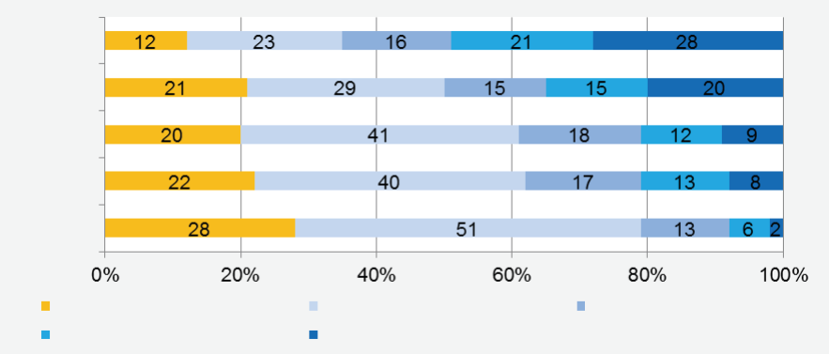
English
Spanish
French
German
Beginner (Pre-A1)
Independant (B1)
Basic (A1)
Advanced independant (B2)
Advanced basic (A2)
Italian

Creating a European indicator for languages
An important purpose of the ESLC is to inform the creation of a European indicator on language competences. A simple proxy of such an indicator can be obtained by taking the average of the proportion of pupils achieving each level in Reading, Listening and Writing. Figures 2 and 3 provide an overview of educational system performance in first and second foreign language by using this indicator. The 'ESLC average' refers to the average across all 16 participating educational systems (See also table 2). The pupil achievement scores are based on the average of the three skills assessed in the ESLC. The tested foreign language (EN - English, FR - French, DE - German, IT - Italian and ES - Spanish) is indicated in brackets.

Figure 2: First foreign language. Percentage of pupils at each level by educational system using global average of the 3 skills
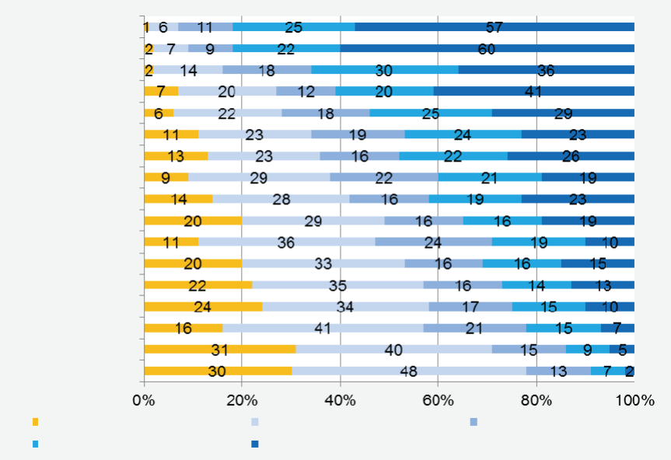
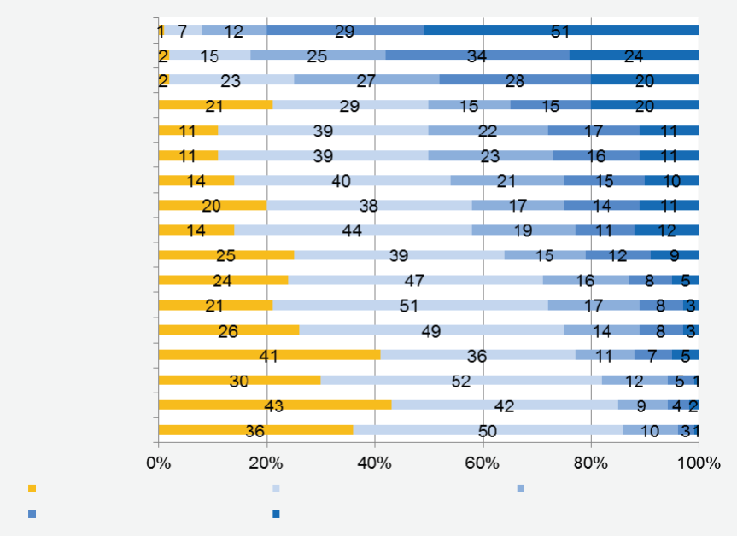
Figure 3: Second foreign language. Percentage of pupils at each level by educational system using global average of the 3 skills
Beginner (Pre-A1)
Independant (B1)
Basic (A1)
Advanced independant (B2)
Advanced basic (A2)
Belgium DE (FR)
Greece (EN)
Croatia (EN)
Slovenia (EN)
Estonia (EN)
Netherlands (EN)
ESLC Average
Bulgaria (EN)
Belgium FR (EN)
Portugal (EN)
Spain (EN)
Poland (EN)
Belgium NL (FR)
France (EN)
UK ENG (FR)
Malta (EN)
Sweden (EN)
Beginner (Pre-A1)
Independant (B1)
Basic (A1)
Advanced independant (B2)
Advanced basic (A2)
Belgium DE (EN)
Greece (FR)
Croatia (DE)
Slovenia (DE)
Estonia (DE)
Netherlands (DE)
ESLC Average
Bulgaria (DE)
Belgium FR (DE)
Portugal (FR)
Spain (FR)
Poland (DE)
Belgium NL (EN)
France (ES)
UK ENG (DE)
Malta (IT)
Sweden (ES)

The educational systems are shown ordered from lower to higher, on the principle that a higher ranking indicates a larger proportion of pupils achieving the independent user levels (B1 and B2), and a smaller proportion achieving the levels of basic user (A1) or beginner (pre-A1).

Figure 2 and 3 illustrate the relative performance of educational systems using this simple proxy of global performance. They are not intended as an adequate summary of the ESLC results. The next round of ESLC should include speaking skills and should provide a basis for a more elaborate indicator.

Findings: the contextual questionnaires
The contextual information collected through the questionnaires seeks to ‘facilitate a more productive comparison of language policies, and language teaching methods
between Member States, with a view to identifying and sharing good practice’ . Thus it focuses on those contextual factors which can be modified through targeted educational policies, such as the age at which foreign language education starts, or the training of teachers. The ESLC maps out differences within and between educational systems regarding three broad policy areas, and evaluates which of these relate to differences in language proficiency. Other factors which are largely beyond the control of policy such as general demographic, social, economic and linguistic contexts are not explicitly discussed in the final report, although data on socio-economic status are collected and are available for analysis by educational systems.

Generally pupils report a rather early start to foreign language learning (before or during primary education) and most commonly they learn two foreign languages. However, considerable differences are still found across educational systems in the exact onset of foreign language learning, the current teaching time and the number of languages offered and learned.
 The results of the ESLC show that an earlier onset is related to higher proficiency in the foreign language tested, as is learning a larger number of foreign languages and of ancient languages.
Policy also aspires to create a language-friendly living and learning environment, where different languages are heard and seen, where speakers of all languages feel welcome and language learning is encouraged. Clear differences between educational systems are seen in the informal language learning opportunities available to pupils (such as pupils' perception of their parents’ knowledge of the foreign language tested, individual trips abroad, the use of dubbing or subtitles in the media, and the pupils’ exposure to the language through traditional and new media).
 A positive relation is observed between proficiency in the tested language and the pupils’ perception of their parents’ knowledge of that language, and their exposure to and use of the tested language through traditional and new media

Differences are found in schools’ degree of language specialization, the availability of ICT facilities, the number of guest teachers from abroad and provisions for pupils with an immigrant background. However, exchange visits for pupils, and participation in school language projects display a relatively low take-up and most aspects concerning classroom practice display relatively less variation across educational systems (such as the use of ICT for foreign language learning and teaching, the relative emphasis teachers place on particular skills or competences, emphasis on similarities between languages, and pupils’ attitudes to their foreign language study, its usefulness and difficulty). Only the amount of foreign language spoken in lessons shows clear differences across educational systems.
 Pupils who find learning the language useful tend to achieve higher levels of foreign language proficiency and pupils who find learning the language difficult lower levels of foreign language proficiency. Also a greater use of the foreign language in lessons by both teachers and pupils shows a positive relation with language proficiency. Overall, differences in language specialization, hosting staff from other language communities, and provisions for immigrant pupils show no clear relationship with foreign language proficiency.

Improving the quality of initial teacher education and ensuring that all practising teachers take part in continuous professional development has been identified as a key factor in securing the quality of school education in general. Overall, most language teachers are well qualified, are educated to a high level, have full certification and are specialised in teaching languages. Also relatively little variation was found between educational systems concerning in-school teaching placements and teaching experience even though differences exist in the number of different languages teachers have taught. Generally, across educational systems only a small proportion of teachers have participated in exchange visits, despite the availability of funding for such visits in a number of educational systems. We did find considerable differences between educational systems in teacher shortages and in the use of and received training in the CEFR, and, to a lesser extent, in a language portfolio; the actual use of a portfolio appears rather low. Concerning continuous professional development, despite clear differences found in the organisation of in-service training (such as financial incentives, when teachers can participate in training and the mode of training), reported participation in and focus of in-service training display less variation across educational systems.
 The different indices related to initial and continued teacher education show little relation to language proficiency. For many indices this lack of a relation can be attributed to a lack of differences within educational systems. For others however, such as the use of and received training in the CEFR, considerable policy differences have been found, and yet these differences do not account for differences in language proficiency.

Challenges for language learning in Europe
The results from the Survey highlight challenges which need to be tackled by the Member States and the EU in order to improve language competences in Europe:

1. Language competences still need to be significantly improved, and educational systems must step up their efforts to prepare all pupils for further education and the labour market. The exchange of good practice within the Open Method of Coordination will constitute one of the main tools in pursuing the Barcelona objective of teaching and mastering at least two foreign languages from a very early age.

2. Language policies should address the creation of language-friendly living and learning environments inside as well as outside schools and other educational institutions. Language policies should promote informal learning opportunities outside school, and consider the exposure to language through traditional and new media, including the effects of using dubbing or subtitles in television and cinemas. Overall, language policy should support that people in general, and young people in particular, feel capable of language learning and see it as useful.

3. The wide range of ability among Member States in language competences indicates the rich potential for peer learning in language policy and learning. The Survey points out those educational systems can make a positive difference with an early onset of foreign language learning, increase the number of foreign languages learnt and promote methods enabling pupils and teachers to use foreign languages for meaningful communication in lessons.

4. The importance of the English language as a basic skill and as a tool for employability and professional development requires concrete actions to further improve competences in this language.

5. While all languages are not equally relevant when entering the labour market, linguistic diversity remains vitally important for cultural and personal development. Therefore, the need to improve language skills for employability in a globalised world must be combined with the promotion of linguistic diversity and intercultural dialogue.

Communication from the Commission to the Council of 13 April 2007 entitled ‘Framework for the European survey on language competences’ [COM (2007) 184 final – Not published in the Official Journal]
Barcelona European Council 15 and 16 March 2002: Presidency conclusions. Barcelona.
Commission Communication of 1 August 2005 - The European Indicator of Language Competence [COM(2005) 356 final - Not published in the Official Journal]
Common European Framework of Reference for Languages: Learning, Teaching, Assessment. Cambridge: Cambridge University Press
Communication from the Commission to the European Parliament and the Council: The European Indicator of Language Competence. COM(2005) 356 final. 5. Brussels.
Language Teaching: In the spotlight. Retrieved from http://ec.europa.eu/education/languages/language-teaching/doc24_en.htm

